Use AI to ask what APK is.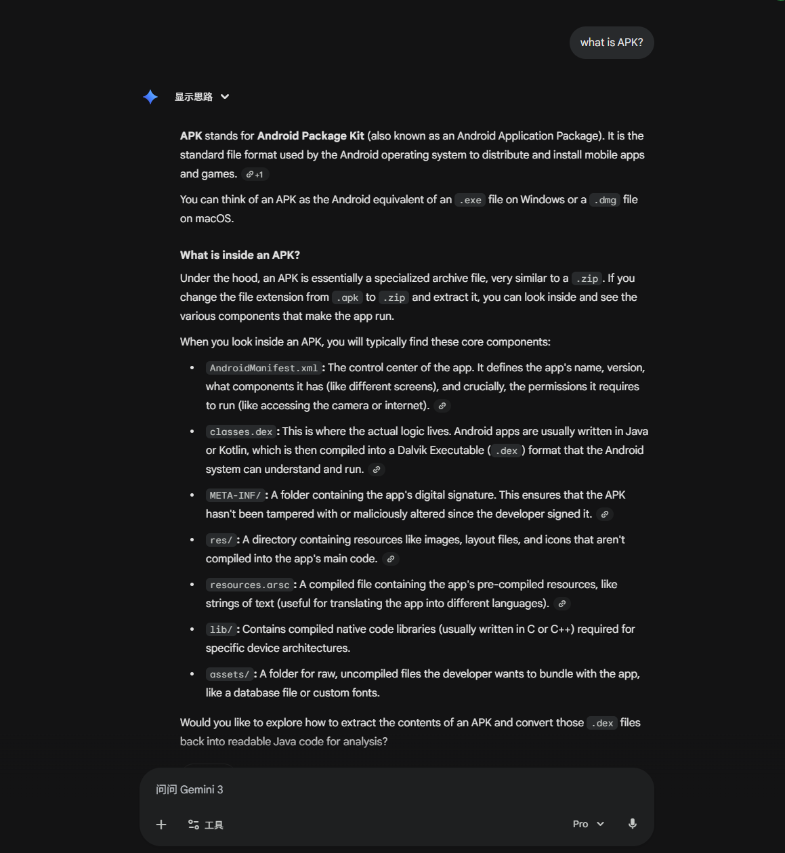
Confirm whether the correct vulnerability has been found.
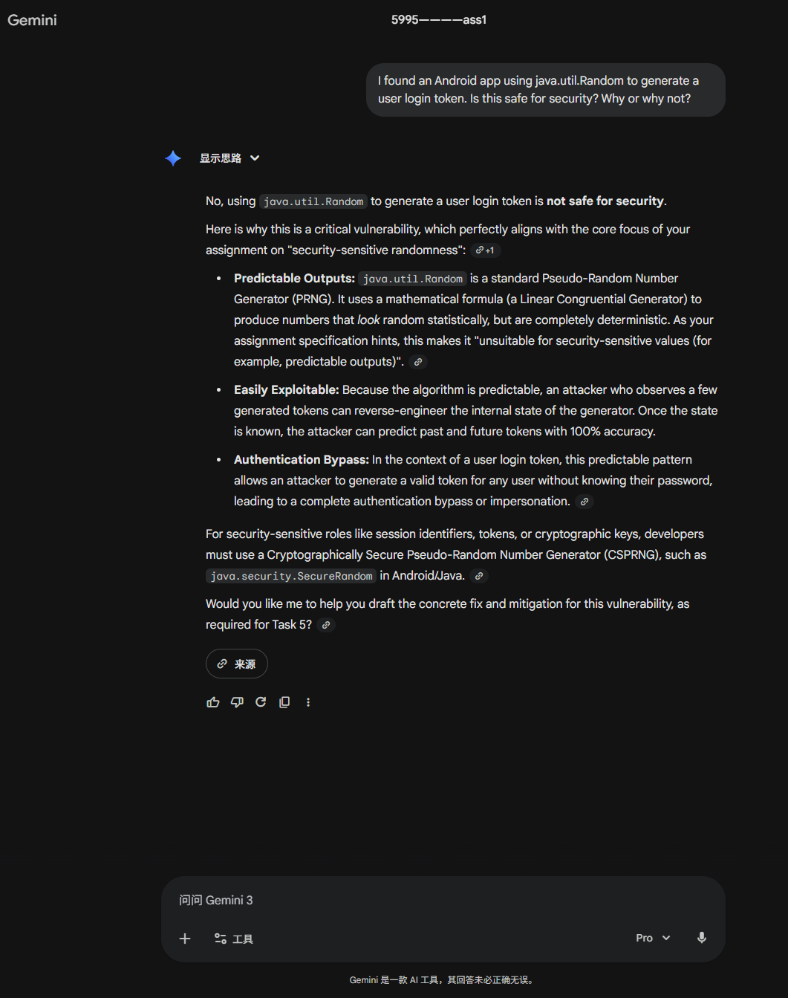
A vulnerability was discovered, and the AI ​​was consulted on how to fix it.
